Dear Parent/guardian
Guidelines - your child should spend between one & two hours each day (Mon – Fri) at their school work.
There is no substitution for reading, so please encourage your child to read a variety of text.
If you need to contact, please email drinaghns@gmail.com or through Seesaw
You are and always will be your child's primary educator. If you decide that the work being sent home by the teacher is unnecessary, then don't do it. Children learn in many different ways and not just through "book learning". Some families will be able to do the schoolwork - others will be under pressure to get it done. Please don't be under any pressure to get the school work prescribed completed.

5th Class (1st of February 2021 – 7th of February 2021)

English
Spellings Spellbound +spellings (week 17)
Reading 160 - 168 (Racing ahead)
Reading Children should be reading a book of their own

Written P170 B,C, D & E
P171 F & G
Just Grammar p23
Seesaw Activities will be posted during the week

Irish
Spellings Craic le Litriú – Aonad 17
Leigh sa bhaile seachtain 19 agus ceisteanna – go to https://my.cjfallon.ie/login and listen to the story daily.
Irish Reading pg 72/73 –(Béigil)
Written ich 76 – Ceisteanna agus freagraí
Ich 77 – Críochnaigh an scéal J & K
Written Irish exercise will be posted on seesaw during the week.
Oral Download Duolingo app and practice Irish for at least 15mins a day on this app.

Frasaí/SF/Verb See last page attached

Maths
Mental Maths daily – week 19
Maths (Weight) page 154, 155 & 156
Tables x11, x12,

Geography
Chapter 7 – Clouds
Read the chapter and answer the following questions.
Activity B page 38
Activity C page 38 & 39
Further Activities will be posted on seesaw during the week

Fifth & Sixth Class

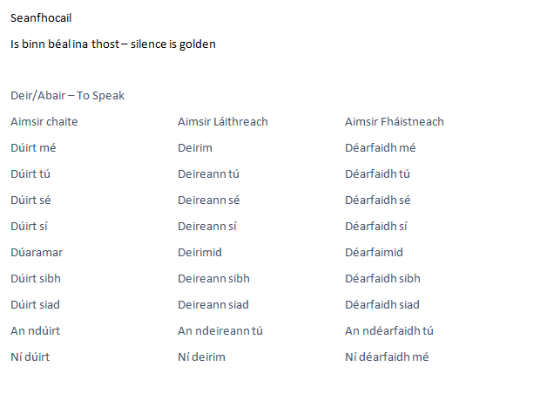

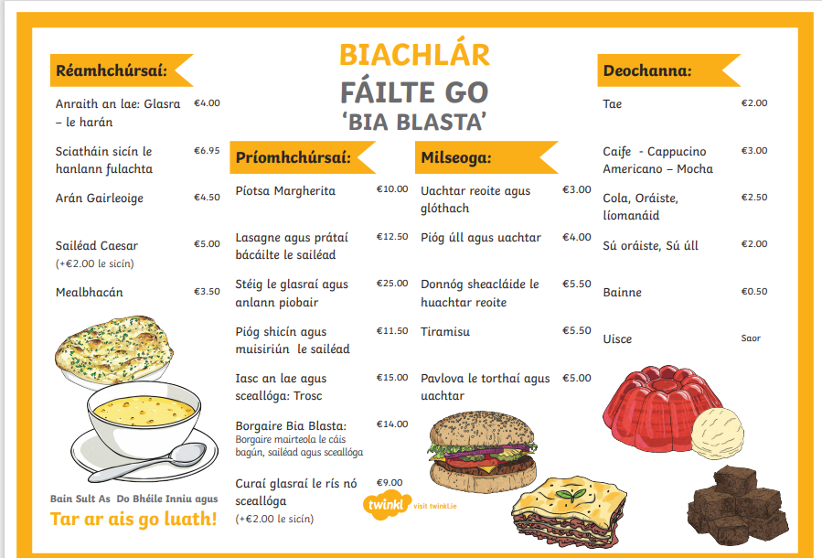

Bosca foclóra
Biachlár - menu
Réamhchúrsaí – starters
Príomhchúrsaí – main courses
Milseoga – dessets
Deochanna – drinks

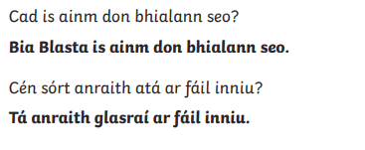
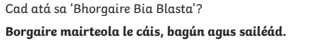
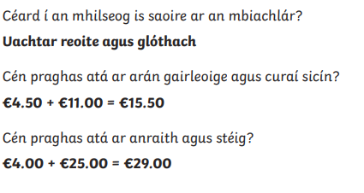

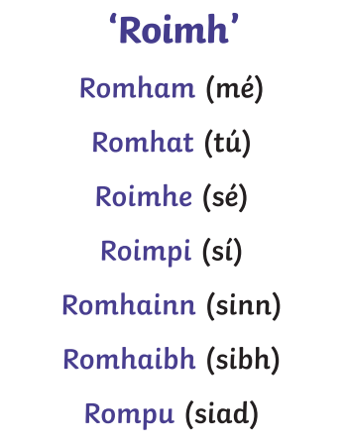

You are welcome

Rinne mé mo obair bhaile roimh mo dhinnéar
I did my homework before my dinner.

